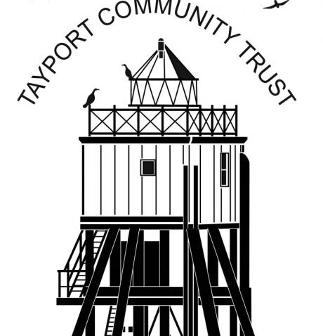
Tayport Community Trust is a Registered Scottish Charity (SC042558)
Warm & Welcome Wednesday
Please join us at the Larick Centre in Tayport every Wednesday from 22nd November 4.30-6.30pm.
We are opening our doors on a Wednesday for soup, sandwich, hot drinks and company. This is free, but donations are always welcome.
There will be activities for all ages and abilities including card & board games and chat in the café space, table tennis and other activities in the Sea Eagle and quiet space for reading or homework in the Kingfisher room. We are open to ideas for other activities, just tell us what you would like.
Come along to join in and/or help out.
Under 16s must be accompanied by an adult.
e-mail shonarobertson@tayportct.org.uk if you want to know more.
If transport is a barrier we may be able to help out-contact Shona above to discuss.

